NAME: ……………………………………………………….......... INDEX NO. …………..

SCHOOL: …………………………………………………………. SIGNATURE: ………..

P530/2
BIOLOGY THEORY
PAPER 2
JULY/AUGUST, 2017
2 Hours 30 Minutes .

RESOURCEFUL MOCK EXAMINATIONS, 2017
Uganda Advanced Certificate of Education
MOCK EXAMINATIONS, 2017
BIOLOGY THEORY
PAPER 2
2 Hours 30 Minutes

INSTRUCTIONS TO CANDIDATES.
- Attempt four numbers in this paper only
- Section A is Compulsory
- In Section B attempt only 3 numbers
- If necessary illustrate using diagrams

FOR EXAMINERS’ USE ONLY
SECTION | Marks | Examiner
I
II
II

Total

SECTION A (40 MKS)

- i) An experiment was carried out to investigate the linear velocity of flow of sap through the
xylem in the trunk and in one of the small branches at the top of a tree in a savannah grass
land.
The figure 1 below shows the results of the experiment plotted on a graph.
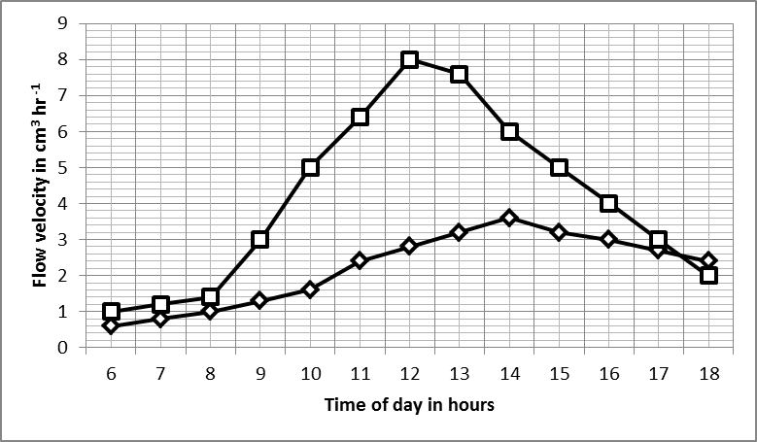

- Compare the linear velocity of flow of sap through the xylem in the trunk and in one of the small branches. (8mks)
- Explain the difference in linear velocity of flow in the circumference of the trunk measured at 1400hrs when compared with that measured at 1800hrs. (3mks)
- What conclusion can you draw about the mechanism by which water passes up the tree using these results. (1mk)
- Explain the properties of water that account for its movement from roots to leaves of very tall plants or trees. (6mks)

ii) Figure 2 below shows effect of Dinitrophenol (DNP) on the uptake of phosphorus by slices of carrot at the same temperature.

Without DNP added
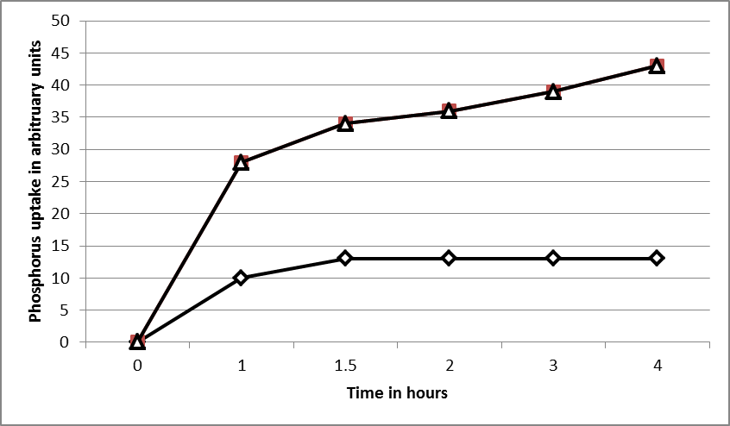

- Describe the uptake of phosphorus without addition of DNP. (3mks)
- What can be deducted from these results with respect to the process of phosphorus uptake by the tree? (6mks)

- Suggest one condition other than inhibitors which might produce an effect similar to the one on the lower graph with DNP in figure 2 above. (2mks)

- In an experiment similar to that described above in (b) but involving phosphate uptake, 16% of the phosphate taken up by barley roots over a short period could be washed out after transferring to pure water again, explain? (3mks)

- Describe how ions reach the xylem from the soil. (7mks)

SECTION B (60 MKS)

- A) Describe the trend of succession in a terrestrial ecosystem. (10mks)
b) Explain the human activities that interfere with nutrient recycling and energy flow in a
terrestrial ecosystem. (10mks)

- a) What is meant by phytochromes? (5mks)
b) Describe the control of flowering in tobacco by phytochromes. (7mks)
c) Describe phototropism in plants. (8mk)

4. a) Describe the structure of the mammalian placenta (5mks)
b) Explain the functions of the mammalian placenta as a barrier. (5mks)
c) Explain the series of events that will take place immediately after fertilization which
leads to formation of a placenta. (10mks)

- a) What is an aerofoil? (2mks)
b) Describe a birds wing as an aerofoil. (8mks)
c) Explain how locomotion is achieved in bipedal mammals. (10mks)

- a) Define the term “cell organelle” (2mks)
b) Explain how ATP molecules can be formed using protons (hydrogen ions) or hydrogen
atoms in different organelles within the plant cells. (12mks)
c) How are the different types of plants adapted to obtain maximum sunlight? (6mks)

END

